





CONAGRA SALES PERFORMANCE ANALYSIS

Meat Substitute Category

**GROUP 5**

|  |  |
| --- | --- |
| **NAME** | **UTDID** |
| **Kushagra Jain** | **KXJ230017** |
| **Pavana Babu Pishe** | **PBP230000** |
| **Tarun Raghu** | **TXR230002** |
| **Hemanth Sadineni** | **HXS230057** |
| **Venkata SNB Subhash Bandaru** | **VXB220040** |

**INDEX**

|  |  |  |
| --- | --- | --- |
| **S.No** | **Title** | **Pages** |
| **1.** | **About Conagra** | **3-6** |
| **2.** | **Pre-Processing of Data** | **6-7** |
| **3.** | **Machine Learning & EDA** | **7-8** |
| **4.** | **Analysis & Recommendations** | **9-14** |
| **5.** | **Impact of Regression Recommendations** | **15** |
| **6.** | **Marketing Insights for Gardein Based on Conjoint Analysis** | **16-17** |
| **7.** | **Summary of Recommendations** | **18** |
| **8.** | **Conclusion** | **19** |
| **9.** | **Annexure** | **20** |

# ABOUT CONAGRA:

Conagra Brands, Inc., one of the largest packaged food companies in North America, has been recognized by industry peers as being able to adapt to dynamic consumer market demand. With a diversified portfolio that embraces frozen, refrigerated, and shelf-stable products, Conagra seems to match convenience, taste, and health needs with contemporary lifestyles quite well.

Gardein, a brand of Conagra, has fundamentally disrupted the burgeoning meat-alternative marketplace. Since it was added to the Conagra portfolio in 2018, Gardein has been experiencing incredible growth: available now in 175 universities, 5,000 restaurants, and over 22,000 retail locations. This very wide selection of plant-derived protein products has positioned Gardein right into the hands of vegetarians, flexitarians, and health-minded consumers.

Gardein is among the top 5 meat substitute brands which is known for its great taste, texture, and nutrition profile. It is also vegan and non-GMO certified, helping to meet the growing consumer demand for new and sustainable choices in food. These are just some of the many achievements that show Conagra's commitment to moving the food industry forward.

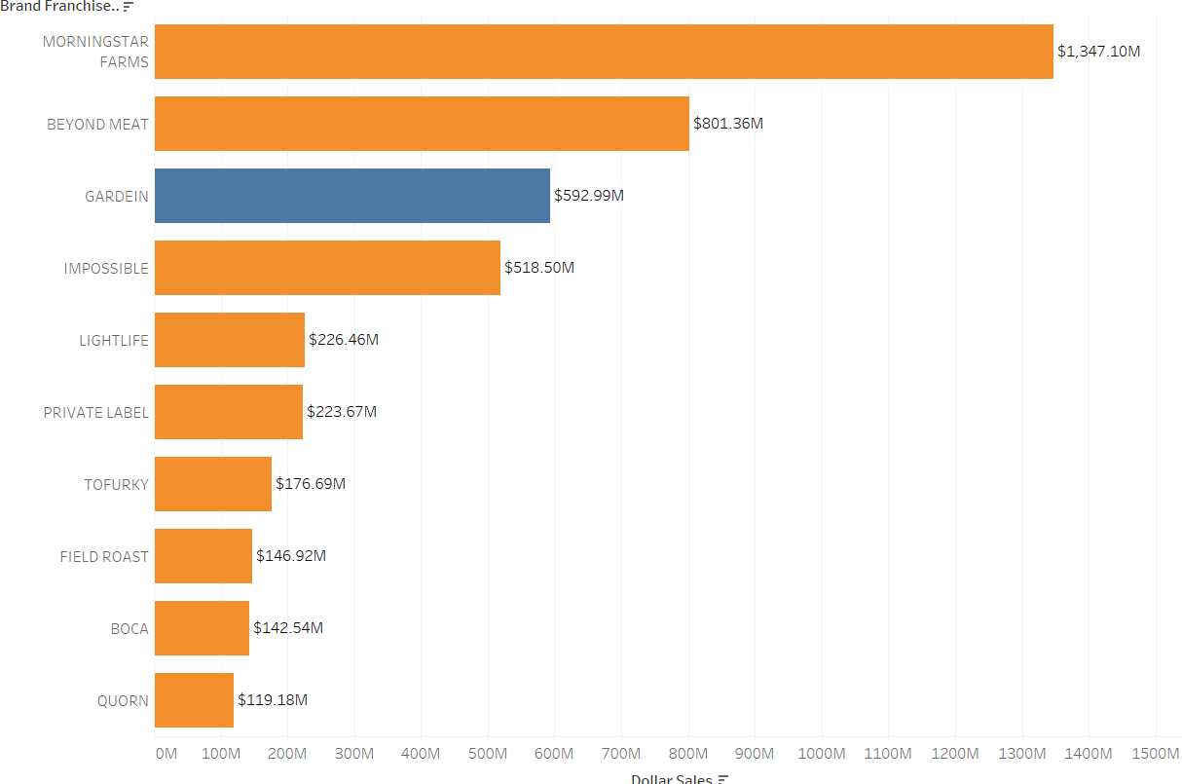

# Regional Performance: Category Development Index (CDI)

CDI comparison across different U.S. regions, pointing out the market penetration and development.

The Mid-South and Northeast regions have the highest CDI values above 115, indicating strong market penetration. On the other hand, CDI levels in the Plains and South-Central regions are below 65; hence, these are considered relatively immature markets with further strategic expansion potential. Unlocking growth opportunities through focused marketing and distribution in those regions is possible.

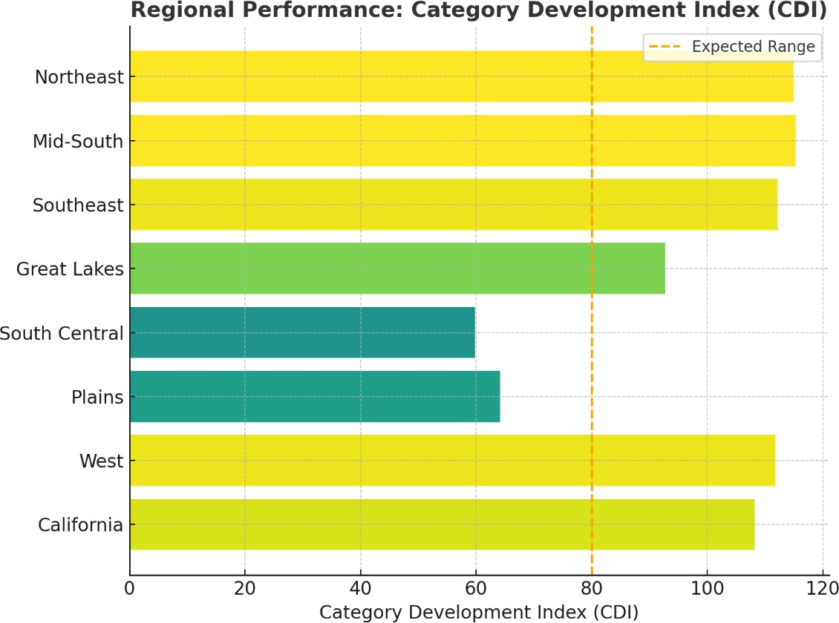

# Market Share and Growth by Product Form

A comparative analysis of the market share together with growth patterns across different product form. Burgers hold a significant 25.5% share of the market, hence positioning it as a staple. Though holding only 9.9% of the market share, nuggets demonstrate the strongest growth at +17.9%, further indicating that consumer preferences are moving toward convenient and versatile choices. Sausage links and crumbles continue with a declining growth pattern once again demonstrating that one has to innovate or reposition such products for them to be considered meaningful to consumers.

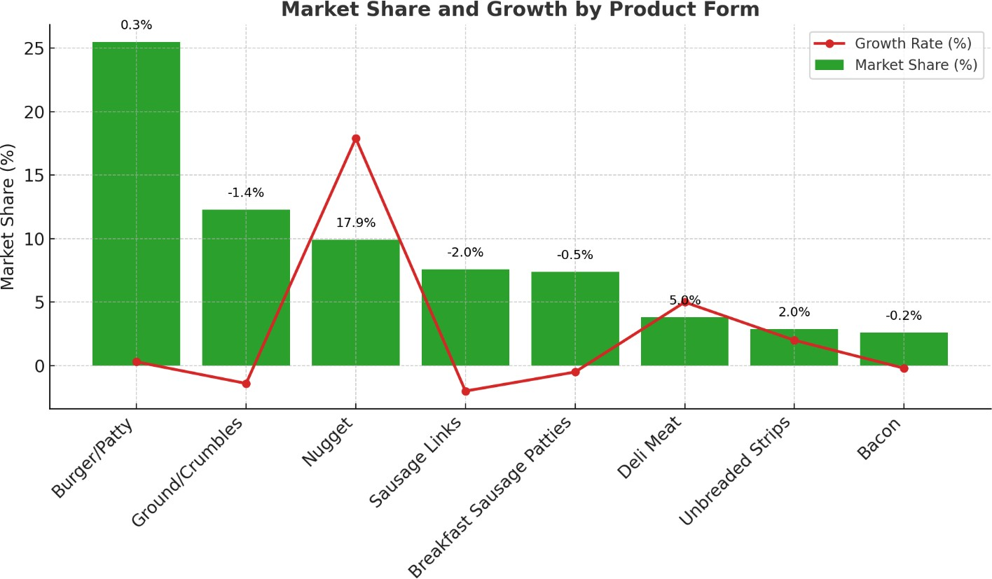

# Flavour Popularity and Growth in Meat Substitutes

Market share and growth trends of various Flavors in the meat substitutes category.

The "Regular" Flavors remains the biggest, accounting for 34.3% of market share. However, the "Chicken" Flavors is a growth leader, up an amazing +83.9%, reflecting growing demand for credible poultry alternatives.

On the other hand, Flavors like "Original" and "Buffalo" exhibit big declines at -17.1% and -14.9%, respectively, probably due to the need for reformulation or repositioning.

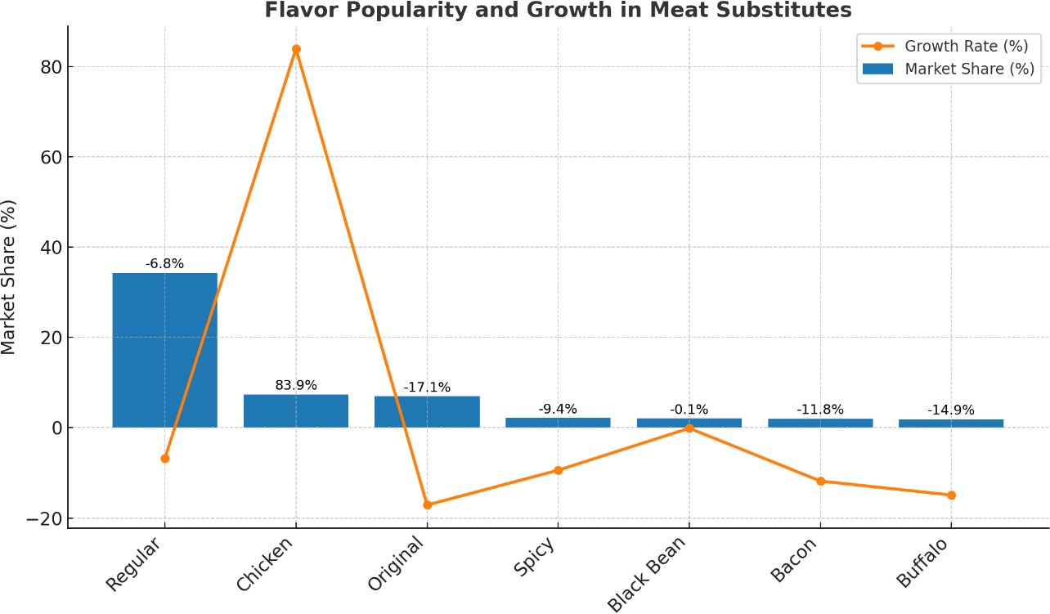

# Buyer Behaviour: New vs Repeat Buyers

Comparison of new versus repeat buyers over the last three years.

While the decline from 10.5 million to 6.7 million new buyers clearly depicts a mature market, where competition would result in more aggressive acquisition strategies on the other hand, relative stability of repeat buyers points toward strong customer loyalty in the existing base, whose maintenance and growth through further retention strategies like a loyalty program or targeted campaign are thus essential.

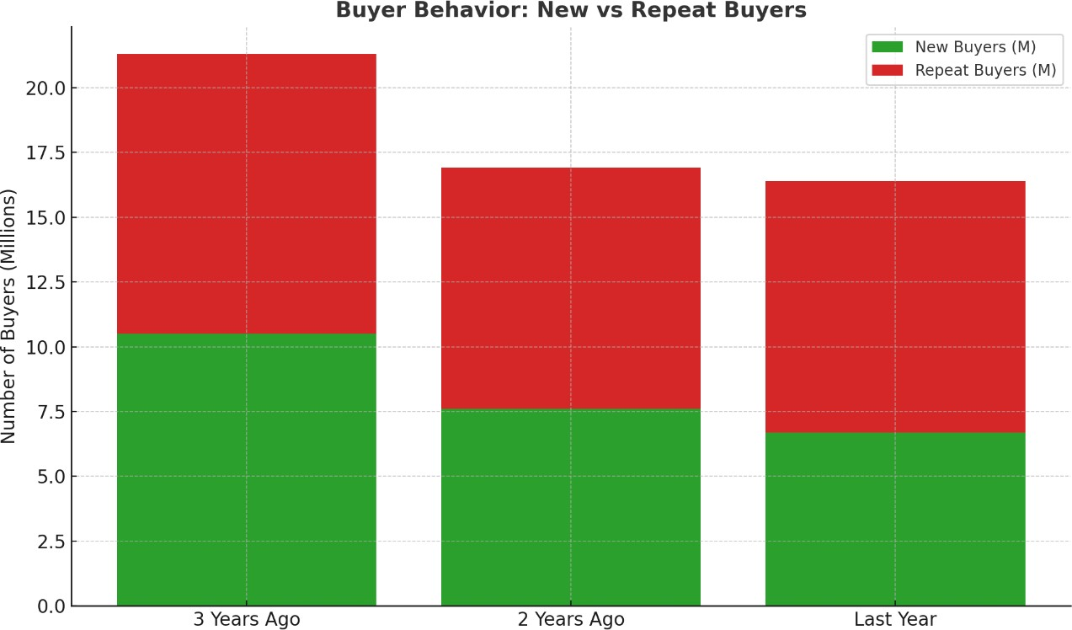

# Average Annual Spend per Buyer by Brand

Compare-and-contrast analysis of the average annual customer expenditure for top brands. Impossible Foods tops the category with an average spend of $60 per buyer, showing strong consumer loyalty and premium positioning. Next are Beyond Meat with $38 and Morningstar Farms with $37, showing competitive pricing and engagement. Gardein has a relatively lower average spend of $36, which implies it has upside by growing better engagement strategies with customers and creating new premium product offerings.

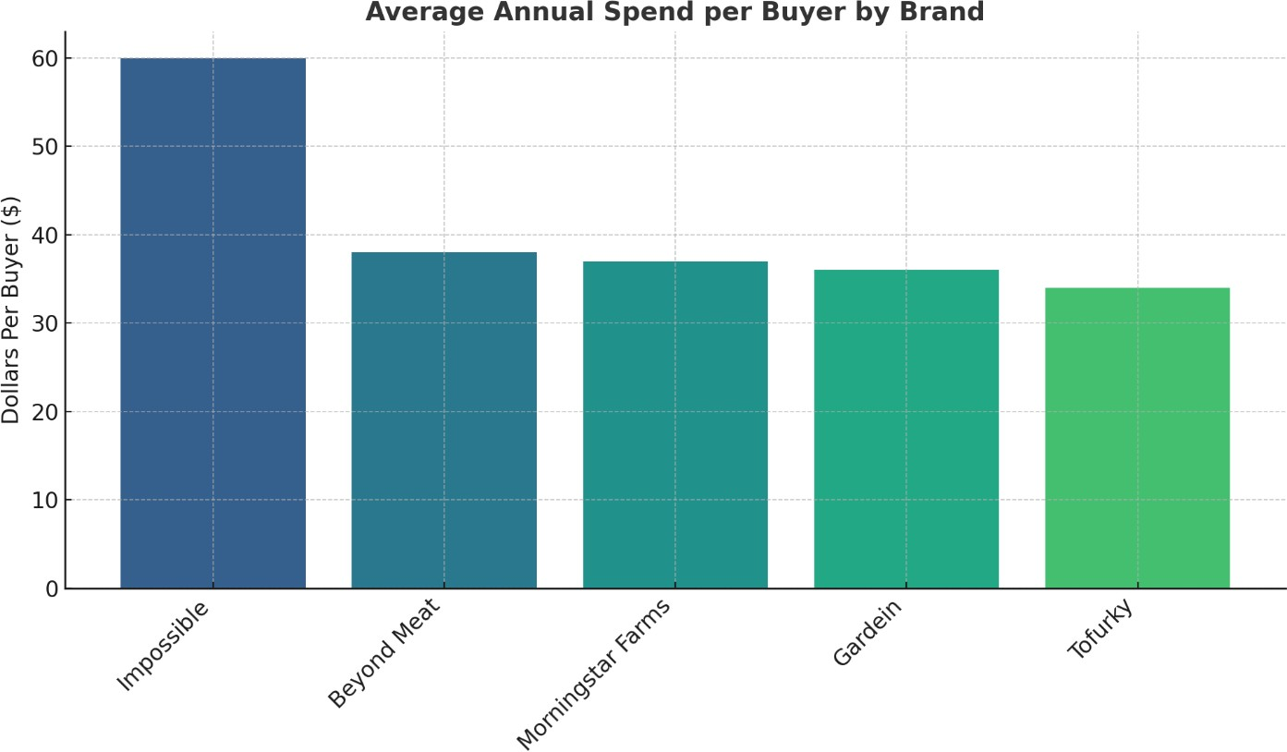

# PRE-PROCESSING OF DATA:

We were provided with meat substitute data from 2020-2024 in separate excel files containing data for multiple brands with weekly sales transaction records. The following pre-processing steps were performed:

1. Converted excel files to parquet files for faster processing
2. Consolidated the yearly separate data into one data frame.
3. Added calculated fields like season, population, normalized sales, IsGardein
4. Dropped unwanted columns which were not required for analysis
5. Categorized product attributes like Form, flavour, Type of Substitute, Type of Meat Substituted, Cooked Info, Packaging. (details in annexure)
6. Imputed numeric columns with Median wherever missing values were present
7. Joined the meat substitute dataset with the Product attributes dataset based on UPC 13 digit.
8. Selected features which were required for analysis like- Price per Unit, ACV weighted distribution.
9. Filtered total US data to avoid redundancy in data.
10. Renamed field names and values to user friendly and understandable notations.

# MACHINE LEARNING AND EDA:

## Hypothesis Testing: ANOVA – Regional Analysis:

**We ran a hypothesis test with ANOVA to test whether there is a significant difference between all the regions in the average values of numerical attributes.**

Null Hypothesis: The average of numerical attributes value is same for all regions Alternate Hypothesis: The average numerical attributes value is not the same for all regions

Conclusion: We can conclude that the average value for numerical attributes is not the same for all regions

## Hypothesis Testing: ANOVA – Seasonal Analysis:

We ran a hypothesis test with ANOVA to test whether there is a significant difference between all the seasons in the average values of numerical attributes.

Null Hypothesis: The average of numerical attributes value is same for all seasons Alternate Hypothesis: The average numerical attributes value is not the same for all seasons

Conclusion: We can conclude that the average value for numerical attributes is not the same for all seasons

## We performed Ridge Regression in Python on the product attributes for Gardein with Dollar Sales as the dependent variable. The results are as follows:

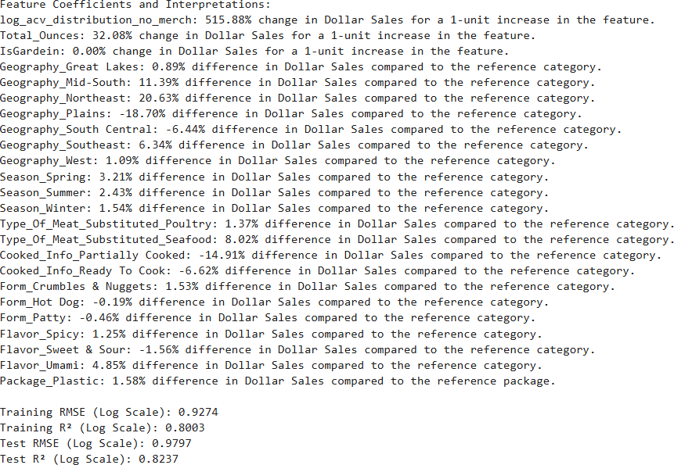

**We also performed conjoint analysis on the dataset after normalizing the dollar sales based on the region population. This was helpful to analyse the interactions between the product attributes. The result of conjoint analysis are as follows:**

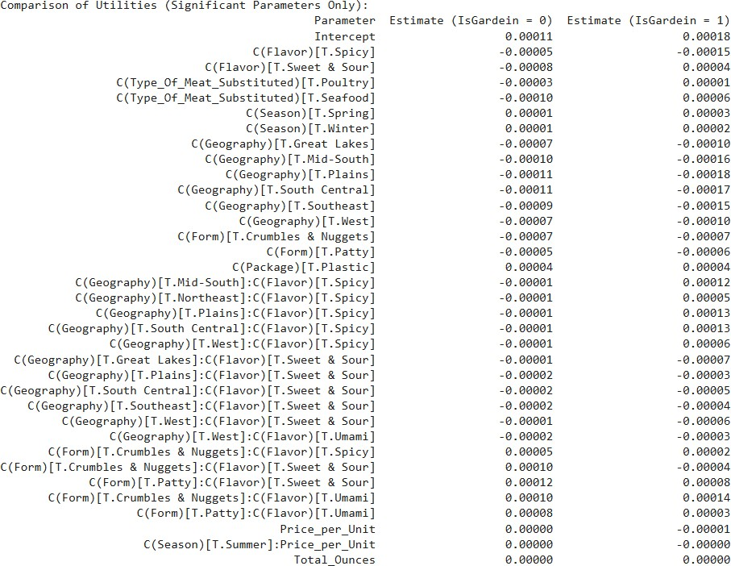

**We also performed Exploratory Data Analysis (EDA) on the cleaned dataset and built visualizations in Tableau**.

# ANALYSIS AND RECOMMENDATIONS:

In this part of our analysis, we identified and analyzed the sales trends in meat substitute products based on product attributes. We started by exploring the basic sales contributions across the product attributes in all brands compared to only Gardein products. We drew an analysis to understand how sales of Gardein products are different/like the industry trends.

Using our exploratory data analysis and the regression outputs and conjoint analysis, we then identified the various threats and opportunities for Gardein products based on product attributes. We studied the impact of categories of attributes on driving sales values of Gardein products. They helped us discover some finer and more detailed trends that EDA previously failed to detect. Using both these observations, we recommended strategies involving the change of product attribute design and production plan. Using the regression output, we also calculated the impact of the said recommendations on the sales values for Gardein products.

## ANALYSIS BY PACKAGE TYPE:

**DOLLAR SALES BASED ON PACKAGE TYPE (ALL BRANDS VS GARDEIN)**

We have broadly divided the packaging into Cardboard/Box and Plastic. By observing the figure above, we can derive that plastic packaging is more preferred by Gardein users. This is backed by the positive coefficient (1.58%) of the regression result.

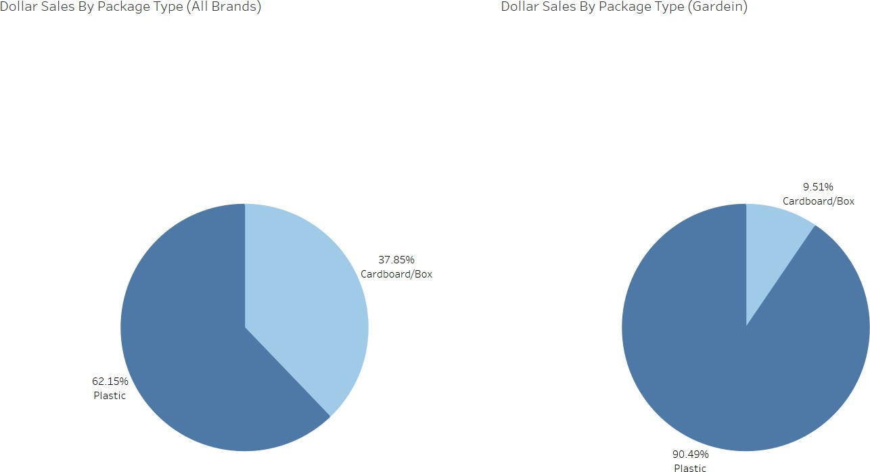

## Recommendation for Gardein:

Continue using plastic packaging, as it remains the preferred choice among customers. Gardein can further convert the packaging for some products from cardboard/box to plastic based. To appeal to environmentally conscious consumers, Gardein can emphasize sustainability by offering recyclable or biodegradable plastic options. Incorporating resealable packaging can further enhance usability, allowing for multiple uses and easier accessibility.

## ANALYSIS BY FORM TYPE:

**DOLLAR SALES BASED ON PRODUCT FORM TYPE (ALL BRANDS VS GARDEIN).**

We can observe that the patty form of products has the highest sales overall, followed by crumbles & nuggets, then hot dogs and bacon. The sales contribution of patty form of products is much higher compared to the other form of products.

Contrastingly, we can observe that Gardein products in the crumbles/nuggets form have the highest sales contribution. It is followed by patty form of products, then bacon form of products, and hot dogs having a negligible contribution.

Based on the regression results, Crumbles & Nuggets show the best performance with a 1.53% sales rise.

Hot Dogs (-0.19%) and Patties (-0.46%) lag, suggesting that these forms require some new ideas or re-thinking

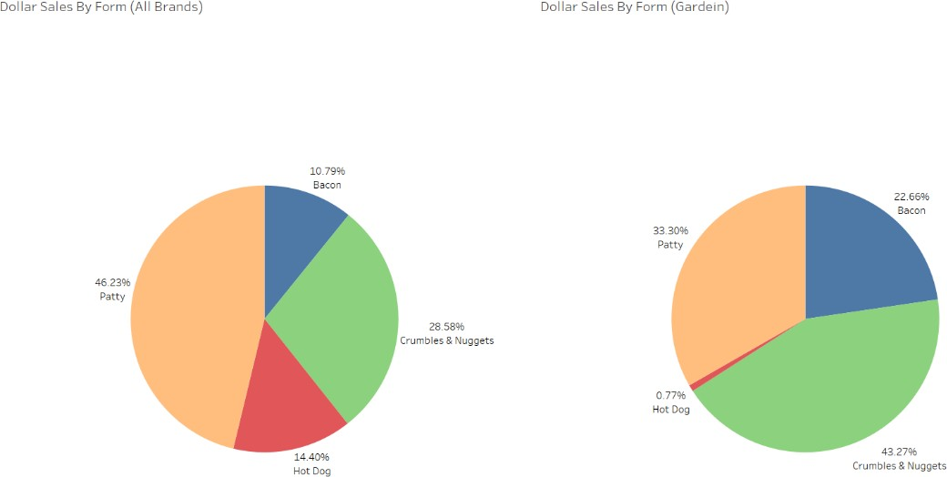

## Recommendation for Gardein:

Focus on growing and scaling Crumbles & Nuggets through versatility, flavour, and convenience. Increase their shelf presence, talk up multiple recipes uses, and include them in marketing campaigns or product bundles to help build overall brand perception. For Hot Dogs and Patties, improve the taste and texture profiles through recipe rework and emphasize the USPs—gourmet Flavors and clean ingredients—to set apart. Conduct experiments with seasonal variations, improved packaging solutions and cross-promotional strategies. Educate consumers on the principles of balanced meals and appropriate occasions for healthy consumption to increase their appeal and prompt trial.

## ANALYSIS BY FLAVOR TYPE:

**DOLLAR SALES BASED ON FLAVOR TYPE (ALL BRANDS VS GARDEIN).**

We can observe that the umami flavour of products has the highest sales contribution in all regions. This is followed by spicy flavour of products, then smoky and sweet & sour. The contribution of umami flavour of products is much higher compared to all other Flavors of products.

We can observe a similar trend in Gardein products. The Umami flavour of products has the highest sales contributions in all regions, which is also much higher compared to other Flavors. However, in the case of Gardein products, sweet & sour products are more popular than smoky and spicy Flavors.

Based on regression, focus on Umami flavour since it has the highest positive impact (4.85% increase). Consider scaling back Sweet & Sour (-1.56%) or Spicy (1.25%) Flavors, unless regional data suggests otherwise.

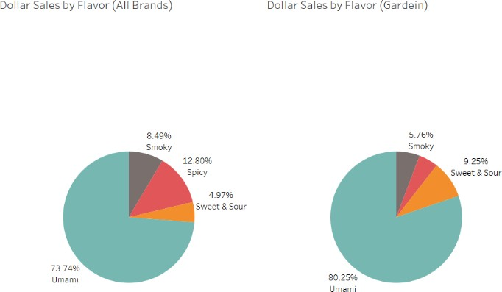

## Recommendation to Gardein:

Prioritize and expand Gardein’s Umami-flavored products given their strong positive impact. Reduce or refine Sweet & Sour and Spicy lines where performance is weak, but maintain them where regional preferences support demand. Leverage targeted marketing and product innovation to capitalize on Umami’s proven appeal while selectively supporting secondary flavors.

## ANALYSIS BY TYPE OF SUBSTITUTE:

**DOLLAR SALES BASED ON TYPE OF SUBSTITUTE (ALL BRANDS VS GARDEIN)-**

We can observe that vegetable-based substitute products have the highest sales contribution in all regions, which is very significantly higher than all other types of substitutes. They are followed by soy-based products and then gluten-based products. The pea-protein based products have a negligible contribution.

Similarly, we can observe that Gardein products have almost only vegetable-based substitute products. The other types of substitutes are negligible in driving sales numbers.

Regression on Other brands suggest products formulated with soy protein outperform those made with pea protein, showing a 9.40% higher contribution to Dollar Sales compared to the reference category. In contrast, pea protein-based products show a -5.39% difference.

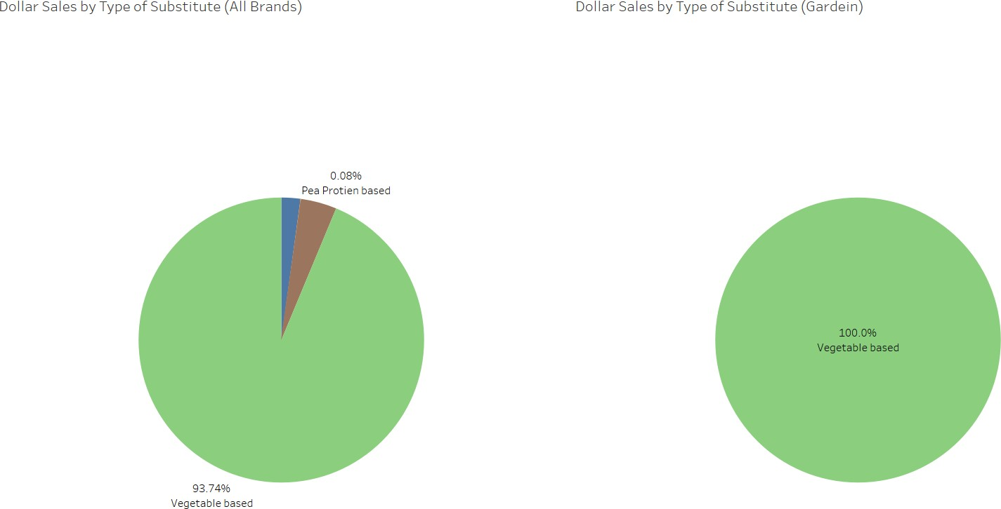

## Recommendation to Gardein:

Continue using vegetable-based packaging, as it has proven profitable. However, given Gardein’s stance against soy, recommending a transition to soy-based products is not advisable.

## ANALYSIS BY TYPE OF MEAT SUBSTITUTE

**DOLLAR SALES BASED ON TYPE OF MEAT SUBSTITUTE (ALL BRANDS VS GARDEIN)-**

We can observe that the Poultry type of meat substituted has the highest sales contribution overall. It is followed closely by Meat, and the Seafood category has a negligible contribution.

Similarly, we can observe that among Gardein products, Poultry type of meat substituted products have the highest sales contribution, which is followed by Meat and then Seafood. However, the contribution of Seafood and Poultry is much more significant in Gardein products compared to overall.

Based on regression results, focus on alternatives to Seafood (8.02% sales increase) and Poultry (1.37% increase).

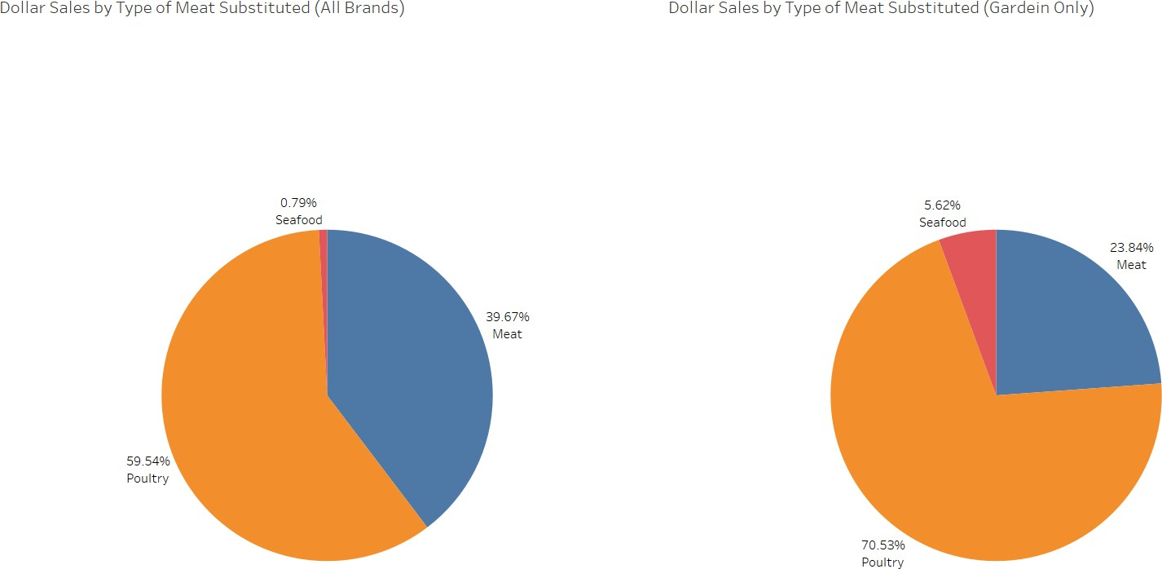

## Recommendation to Gardein:

We recommend Gardein to focus their sales and marketing strategies on seafood substitute products, as it seems from the data that Gardein specializes on seafood substitute products. We also recommend Gardein to reduce the production of meat substitute products and focus on poultry substitute products as they too are a good driver of sales.

## ANALYSIS ON COOKED INFO TYPE:

**DOLLAR SALES BASED ON COOKED INFO TYPE (ALL BRANDS VS GARDEIN)-**

We can observe that ready to cook products have the highest contribution to sales value followed closely by partially cooked and then fully cooked. The distribution of sales between these categories is somewhat even.

Similarly, we can observe that the ready to cook products of Gardein have the highest sales in all regions. However, the sales of ready to cook products are very significantly higher than the other cooked info type of products.

Regression results suggest 14.91% decline if products are partially cooked and 6.61% decline if products are ready to cook.

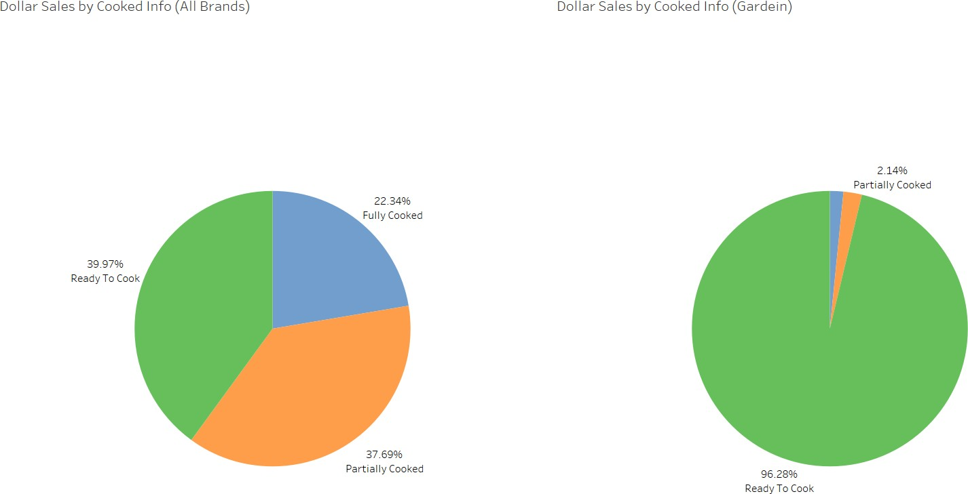

## Recommendation to Gardein:

We recommend Gardein to focus on only fully cooked type of products and reduce their usage of partially cooked and ready to cook type of products. Since partially cooked and ready to cook are negative drivers of sales, we recommend heavily diluting producing these types of products, and focus on fully cooked products instead.

# IMPACT OF REGRESSION RECOMMENDATIONS:

Based on our data-based insights, the macro and micro sales trends, and our regression output, we created a scenario manager which computes the impact of percentage change in the usage of product attributes on the sales of Gardein products. This report can be used to do an intuitive cost-benefit analysis.

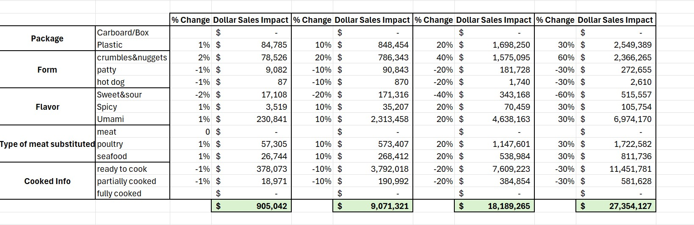

## Marketing Insights for Gardein Based on Conjoint Analysis:

**Flavor and Geography:**

## Spicy flavour:

* 1. Mid-South:

1. IsGardein = 0: p < 0.05, estimate = -0.00001.
2. IsGardein = 1: p < 0.05, estimate = 0.00012.

## Insight: Gardein does better with Spicy flavour in Mid-South compared to competitors. Therefore, this could be a place for focused marketing.

* 1. Southeast:

1. IsGardein = 0: p < 0.05, estimate = -0.00001.
2. IsGardein = 1: p < 0.05, estimate = 0.00012.

## Insight: Like Mid-South, Gardein is exhibiting an intense positive utility for the Southeast region with a spicy flavor that is lacking among the competition.

1. **Sweet & Sour flavour:**
   1. Great Lakes:
2. IsGardein = 0: p < 0.05, estimate = -0.00001.
3. IsGardein = 1: p < 0.05, estimate = -0.00007.

## Insight: Gardein, just like the competitors, did a terrible job of leveraging the Sweet & Sour flavor for the Great Lakes-a terrible place/terrible flavor for any product.

* 1. West:

1. IsGardein = 0: p < 0.05, estimate = -0.00001.
2. IsGardein = 1: p < 0.05, estimate = -0.00006.

## Insight: Challenges in the West for Gardein and competitors to take this Sweet & Sour flavor across; however, slight better utility of Gardein indicates it can make a kill with proper marketing.

1. **Flavor of Umami Variety:**
   1. Plains:
2. IsGardein = 0: p < 0.05, estimate = -0.00002.
3. IsGardein = 1: p < 0.05, estimate = 0.00013.

## Insight: Gardein has a considerably higher performance than competitors, with Umami flavor in Plains, which suggests there is an unsupplied demand.

* 1. Southeast:

1. IsGardein = 0: p < 0.05, estimate = -0.00001.
2. IsGardein = 1: p < 0.05, estimate = 0.00012.

## Insight: Umami flavor significantly appeals to Gardein's target audience in the Southeast. This could be leveraged further.

**Flavor and Product Form:**

## Spicy Flavor with Crumbles & Nuggets:

* 1. IsGardein = 0: p < 0.05, estimate = 0.00005.
  2. IsGardein = 1: p < 0.05, estimate = 0.00002.

## Insight: Gardein's utility for Spicy Crumbles & Nuggets is lower than competitors, indicating a need for reformulation or stronger marketing.

1. **Sweet & Sour Flavor with Patties:**
   1. IsGardein = 0: p < 0.05, estimate = 0.00012.
   2. IsGardein = 1: p < 0.05, estimate = 0.00008.

## Insight: Competitors perform slightly better with Sweet & Sour Patties, but Gardein still has positive utility, suggesting the category remains viable.

1. **Umami Flavor with Crumbles & Nuggets:**
   1. IsGardein = 0: p < 0.05, estimate = 0.00010.
   2. IsGardein = 1: p < 0.05, estimate = 0.00014.

## Insight: Gardein outperforms the competitors for Umami Crumbles & Nuggets, and this is a strong product category to emphasize.

**Type of Substitute and Cooking Information**:

## Pea Protein-Based with Ready-to-Cook:

* 1. IsGardein = 0: p < 0.05, estimate = -0.00002.
  2. IsGardein = 1: p < 0.05, estimate = -0.00002.

## Insight: Both Gardein and competitors are doing poorly with Pea Protein in Ready-to-Cook format, thus reinforcing the idea to stay away from this combination.

1. **Soy-Based with Partially Cooked:**
   1. IsGardein = 0: p < 0.05, estimate = -0.00001.
   2. IsGardein = 1: p < 0.05, estimate = 0.00002.

## Insight: Gardein has performed on higher utility than its competitors in this space; however, overall utilities indicate further scope of improvement.

**Key Recommendations:**

## Geographic Targeting:

**a .Spitfire and Umami flavour will resonate the most with Mid-South and Southeast states.**

## b .Consider Plains for Umami flavour as it shows strong potential for Gardein compared to competitors.

1. **Product Form Innovations:**

## a .Emphasize Umami Crumbles & Nuggets, where Gardein significantly outperforms competitors.

**b. Reassess the viability of Spicy Crumbles & Nuggets due to lower utility.**

## Flavor Reformulation:

* 1. **Improve Spicy products' appeal in underperforming regions like Great Lakes and West.**

## Consider new marketing strategies for Sweet & Sour flavour in regions with moderate performance.

**SUMMARY OF RECOMMENDATIONS**

|  |  |  |
| --- | --- | --- |
| Product Attribute | Key Insight | Recommendation |
| Packaging | Plastic Packaging is preferred and profitable | Continue using plastic packaging; consider recyclable or  biodegradable options |
| Product Form | Crumbles and Nuggets outperform; Hot Dogs & Patties underperform. | Focus on scaling Crumbles & Nuggets; reformulate and reposition Hot Dogs & Patties |
| Flavor | Umami flavor strongest (+4.85%);  , Sweet & Sour (-1.56%) and Spicy (1.25%) weaker. | Prioritize Umami; scale back or refine Sweet & Sour and Spicy unless regional data supports demand |
| Type of Substitute | Seafood (+8.02%) and Poultry (+1.37%) are strong drivers. | Emphasize Seafood and Poultry substitutes; reduce focus on less impactful Meat substitutes. |
| Cooked Info Type | Fully cooked products perform better than partially or ready-to-  cook. | Focus on fully cooked products; reduce partially cooked and ready-  to-cook offerings. |
| Regional Targeting | Mid-South, Northeast strong; Plains, South-Central weaker. | Increase marketing in Plains and South-Central; maintain leadership in Mid-South and Northeast. |
| Flavor & Region (Conjoint) | Spicy and Umami flavors excel in Mid-South, Southeast, and Plains for Gardein. | Tailor flavor strategies regionally (Umami in Plains, Spicy in Southeast/Mid-South) to strengthen competitive edge. |

|  |  |  |
| --- | --- | --- |
| Spicy flavor in Southeast | Strong positive response for Spicy in the Southeast region | Boost regional campaigns to highlight strong appeal; leverage local partnerships |
| Spicy flavor in Mid-South | Gardein outperforms competitors with Spicy flavor here | Target promotions to outcompete  rivals; align with regional preferences. |
| Umami in Plains | Gardein excels with Umami flavor in the Plains. | Strong performance; expand promotions to solidify market leadership. |
| Umami in Southeast | Umami flavor strongly appeals in the Southeast region. | Significant appeal; focus on region-specific campaigns. |
| Umami in Crumbles and Nuggets form | Strong positive result, indicating a key focus area for Gardein. | Key growth area; invest in innovation and marketing. |
| Soy-Based in Partial Cooked | Partially Cooked | Moderate potential; refine taste and convenience. |
| Sweet & Sour in Patties | Positive utility for Gardein; slight area for further enhancement. | Positive response; optimize flavor and marketing. |

## CONCLUSION

We did a comprehensive analysis of the sales trend in the meat substitute market showed big patterns and key insights of the data. Analysis of the market dynamics and identification of specific opportunities and challenges relevant to the Gardein product portfolio allowed for the development of data-driven actionable to improve sales and strengthen market share. In addition, we measured the short-term impact of our recommendations to enable detailed cost-benefit analysis for data-driven decision-making.

Our methodology integrated sophisticated analytics with strategic business intelligence to ensure recommendations would be actionable and impactful for the Gardein marketing team. By effectively integrating data-informed strategies with a deep understanding of market dynamics and competitive environments, we delivered to the Gardein team a practicable roadmap for success.

We would like to express our strongest appreciation to the Conagra team, especially Professor Shervin Tehrani, for giving us this great opportunity to invest our expertise in solving an actual business problem. It was impossible without their input and help. Most important, we are extremely appreciative to Professor Shervin for his continuous support throughout the course of the project.

ANNEXURE:

## Package Categories:

|  |  |
| --- | --- |
| **Plastic** | **Cardboard/Box** |
| RESEALABLE PLASTIC BAG | CARDBOARD BOX |
| PLASTIC BAG | CARDBOARD BOX & WINDOW |
| INDIVIDUAL POUCH IN RESEALABLE PLASTIC BAG | CARTON |
| RESEALABLE PLASTIC PEG BAG | PAPER WRAPPED |
| RESEALABLE STAND-UP BAG | CARDBOARD SLEEVE & VACUUM PACKED |
| MICROWAVEABLE SAFE STAND-UP POUCH | INDIVIDUALLY WRAPPED IN BOX |
| PLASTIC PEG BAG | VACUUM PACKED |
| VACUUM PACKAGED PLASTIC | VACUUM PACKED IN SLEEVE |
| PLASTIC WRAPPED | BOX |

|  |  |
| --- | --- |
| PLASTIC WRAPPED IN CARDBOARD SLEEVE | BAG IN BOX |
| PLASTIC WRAP TRAY |  |
| PLASTIC WRAP IN BOX |  |
| PLASTIC CONTAINER IN SLEEVE |  |
| PLASTIC TRAY IN CARDBOARD SLEEVE |  |
| PLASTIC TRAY IN SLEEVE |  |
| PLASTIC CONTAINER |  |
| PLASTIC TUB |  |
| PLASTIC BAG IN BOX |  |
| PEGGED PLASTIC WRAP TRAY |  |

**Total Count Categories:**

|  |  |
| --- | --- |
| Small Count | 0-5 |
| Medium Count | 5-15 |
| Large Count | 15+ |

## Total Ounces Categories:

|  |  |
| --- | --- |
| Small Volume | 0.0 - 10.0 |
| Medium Volume | 10.1 - 20.0 |
| Large Volume | 20.1 + |

**Product Form Categories:**

|  |  |  |  |
| --- | --- | --- | --- |
| **Patty** | **Nuggets & Crumbles** | **Bacon** | **Hot Dog** |

|  |  |  |  |
| --- | --- | --- | --- |
| BURGER | NUGGET | SLICED | HOT DOG |
| BURGER PATTY | FUN NUGGETS | STRIP | LINK |
| PATTY | BITE | SLICE | DINNER SAUSAGE LINK |
| BREAKFAST PATTY | BREAKFAST BITES | ULTRA THIN SLICE | BRATWURST |
| SAUSAGE PATTY | POPCORN | DELI SLICED | FRANK |
| BREAKFAST SAUSAGE PATTY | FINGER | STEAK | BREAKFAST LINK |
| SLIDER | CHUNK | FILET | SPLIT ROPE |
| CAKE | TENDERS | CUTLET | ROPE |
| MEATBALL | TENDER | ROAST | BREAKFAST SAUSAGE LINK |
| BALL | PIECE | WHOLE | STICK |
| LOAF | WING |  | ROLL |
| MEAT LOAF | DICED |  | DINNER LINK |
| GIZZARD | DIPPER |  | SAUSAGE |
| BREAST | FRIES |  | BREAKFAST SAUSAGE ROLL |
| BAR | CRUMBLE |  | BINGS |
| NOT STATED ON PACKAGE | GROUND |  |  |
| BLOCK | SHREDS |  |  |
| BAO BUN | SHREDDED |  |  |
| SPARE RIBS | PULLED |  |  |
|  | TIP |  |  |
|  | CUBE |  |  |
|  | CUT |  |  |

|  |  |  |  |
| --- | --- | --- | --- |
|  | CHUB |  |  |
|  | POPPER |  |  |
|  | DRUMSTICK |  |  |
|  | RIBLET |  |  |

## Product Flavor / Scent Categories:

**UMAMI**: "BLACK BEAN", "CALIFORNIA VEGETABLE", "GARDEN VEGETABLE", "REGULAR", "THE CLASSIC", "SONOMA", "SALAMI", "ORIGINAL", "BEEF", "HEIRLOOM BEAN", "KALE", "MUSHROOM RISOTTO", "PERFECT", "SUPER GREENS", "ROOT VEGETABLE", "BLACK RICE", "PORTABELLO", "BACON", "CHEESE", "CHORIZO", "MEDITERRANEAN CHICK PEAS", "MEAT LOVERS", "TOMATO & BASIL PIZZA", "VEGETABLE", "VEGETABLE LOVERS", "VEGETABLE MEAT LOVER", "WHITE BEAN CHILI", "CLASSIC", "VEGETABLE GRILLER ORIGINAL", "VEGETABLE GRILLER PRIME", "GRILLED", "BEET", "CARROT", "MULTI VEGETABLE", "ASIAN VEGETABLE", "BLACK BEAN & VEGETABLE", "CHEDDAR", "HERB & SPICE", "KALE & QUINOA", "LIGHTLY SEASONED", "TUSCAN KALE WHITE BEAN", "GREEK MOUSSAKA", "CHICK PEAS & TAHINI", "GARDEN HERB", "SHIITAKE MUSHROOM", "SOUTH WEST", "ALL AMERICAN", "GARDEN VARIETY", "PORTABELLO MUSHROOM & CHEESE", "WILD MUSHROOM CAULIFLOWER HEMPSEED", "ROASTED BEET & KALE", "HERBY GARLIC GREENS", "TURKEY", "CHICKEN", "CHICKEN SCALOPPINI", "SAVORY", "7 GRAIN", "PARMESAN GARLIC", "VEGETABLE CHICKEN", "ORIGINAL TURKEY", "PESTO MOZZARELLA", "TURKEY ROAST", "SAVORY CHICKEN", "5 SPICE", "SEASONED", "CHICKEN LIGHTLY SEASONED", "BROCCOLI BOOST", "MUSHROOM", "VEGETARIAN", "WILD MUSHROOM", "UNSEASONED", "LUPINI BEAN", "LENTIL SAGE", "CELEBRATION", "TRADITIONAL", "BRATWURST", "CHICK PEAS & RED PEPPER", "FLAX", "3 GRAIN", "WHITE BEAN & KALE", "HOT DOG", "MEDITERRANEAN", "TASTY", "TUSCAN VEGETABLE SAUSAGE", "THE STALLION", "BLACK FOREST HAM", "KIELBASA", "MUSHROOM & VEGETABLE", "HOMESTYLE", "SIMPLY SEASONED", "CANADIAN BACON", "PIZZA PEPPERONI", "BOLOGNA", "HAM", "PHILLY STEAK", "HERB ROASTED", "SAVORY ORIGINAL", "5 GRAIN", "LENTIL", "BEETROOT & BEAN", "ROASTED GARLIC & QUINOA", "ORIGINAL BEEFY", "VEGETABLE PORK", "BUTTER", "PARMIGIANA", "SAVORY TUSCAN STYLE", "SAUSAGE", "NEW ENGLAND STYLE", "ITALIAN PEPPERONI", "CHICKEN APPLE SAUSAGE", "GREEN CHILE CHEDDAR", "GINGER SCALLION", "OVEN ROASTED TURKEY", "CORNED BEEF", "GROUND BEEF", "EGGPLANT", "FRENCH HERB", "BROWN RICE & GARBANZO & WHITE BEAN", "GRILLED VEGETABLE", "WALNUT", "SAVORY MUSHROOM", "GARDEN BROILER", "LENTIL BARLEY", "QUINOA", "WALNUT & CHEESE", "MUSHROOM RICE", "PORTABELLO QUINOA", "SPROUTED QUINOA CHIA", "THE OG", "GARLIC & HERB", "SAVORY VEGETABLE SAUSAGE", "SAVORY VEGETABLE", "HARVEST BLEND", "FISH", "SAVORY MUSHROOM & ROASTED GARLIC", "SUN DRIED TOMATO & SPINACH", "MUSHROOM & CHEESE", "BEET & KALE", "SALISBURY STYLE", "ITALIAN STYLE", "GRAIN & SEED MEDLEY", "STEAK", "ORIGINAL BRAT", "BEAN", "EL CAPITAN", "LEMON HERB", "SPINACH", "CALIFORNIA BURGER", "VEGAN", "MULTI GRAIN", "CRANBERRY & GOAT CHEESE", "SUNRICE", "ULTIMATE BLACK BEAN", "ULTIMATE", "CAULIFLOWER", "ARTICHOKE", "THE BIG FRY", "TRUFFLE",

"ITALIAN GARLIC & FENNEL", "SPINACH CHICKEN", "SEA SALT & PEPPER", "CALIFORNIA STYLE", "GREEN & BEAN MEDLEY", "GRAIN & HERB", "PEAS & CARROT", "BASIL PESTO", "STEAKHOUSE STYLE", "MUSHROOM QUINOA", "WHITE TRUFFLE & BLACK BEAN", "MUSHROOM MISO", "SWEDISH", "MUSHROOM & WINE", "TOMATO & SPINACH", "GARLIC", "GARDEN", "CALIFORNIA", "FALAFEL", "ORIGINAL SAUSAGE", "QUINOA CRUNCH", "SPINACH PESTO", "SUN DRIED TOMATO BASIL", "ASIAN", "CHICK PEAS SWEET POTATO", "GARDEN FRESH", "CLASSIC PIZZERIA", "CHICK PEAS & SUNFLOWER SEED", "BLACK BEAN & PLANTAIN", "BLACK BEAN QUINOA", "BUTTERMILK", "GREEK"

**SWEET & SOUR**: "SWEET & SOUR", "MAPLE SAUSAGE", "APPLE MAPLE", "SWEET HEAT", "BEET HAZELNUT", "CRANBERRY", "THAI COCONUT", "SWEET POTATO & VEGETABLE", "CURRIED SWEET POTATO", "MANDARIN ORANGE", "SWEET & TANGY", "SAVORY ORANGE", "SWEET APPLE", "MAPLE", "SMOKEY SAVORY", "MAPLE SWEET", "ITALIAN", "PUMPKIN & SPINACH", "SUNRISE TRAIL MIX", "SWEET PEPPER", "ADZUKI BEAN & SWEET POTATO", "SWEET POTATO", "SUNFLOWER", "CARIBBEAN STYLE", "PLANTAIN", "SWEET & SPICY", "PEPPER", "LEMON", "LEMON PEPPER", "CITRUS", "SPARERIB", "SWEET CURRY", "CARROT COCONUT CURRY", "SEASON & LIME", "SWEET POTATO & RED QUINOA", "SWEET SUNSHINE", "CORN", "BLACK BEAN & PINEAPPLE", "SWEET & SAVORY", "SWEET & SRIGINAL", "MANGO & BASIL", "MANGO CHIPOTLE", "APPLE SAUSAGE", "LEMON DILL", "SALMON", "SWEET POTATO QUINOA CRUNCH", "FALAFEL & SESAME", "SPROUTED QUNIOA CHIA", "SWEET HEAT BEET", "HAZELNUT CRANBERRY", "JUICY", "SWEET ITALIAN", "SWEET POTATO SUNFLOWER", "SWEET & SPICY PEPPER", "SWEET CURRY CARROT", "SWEET SUNSHINE CORN"

**SPICY:** "FEISTY", "CHIPOTLE BLACK BEAN", "SIZZLING SZECHUAN", "SPICY", "BOMBAY CURRY", "KOREAN", "SPICY GREEN CHILI", "ZESTY ITALIAN", "BLACK BEAN CHIPOTLE", "HOT & SPICY SAUSAGE", "ITALIAN SAUSAGE", "SPICEY INDIAN VEGETABLE", "SPICY BLACK BEAN", "GREEN CHILE & PINTO BEAN", "SAUCY BUFFALO", "PINTO HABANERO", "POBLANO BLACK BEAN", "SMOKY & SPICY", "PEPPER SEASONING", "SPICY ITALIAN HEMPSEED", "BLACK PEPPER", "SOUTHWEST STYLE BEET", "CHIPOTLE LIME", "NASHVILLE HOT", "BUFFALO", "SPICY CHICKEN", "HOT ITALIAN", "SPICY SAUSAGE", "TACO", "ITALIAN", "CAJUN", "SPICY SICHUAN", "SPICY GARLIC", "MEXICAN CHIPOTLE", "CHIPOTLE", "MEXICAN", "CURRY", "EL ZAPATISTA", "SESAME GINGER", "PEPPERED", "MILD HOT", "SPICY INDIAN", "MASALA", "ZESTY MEXICAN", "BUFFALO TEMPEH", "EL GUAPO", "SPICY THAI", "TANDOORI SPICE", "BAJA", "SPICY ITALIAN", "SPICY FALAFEL", "MADRAS CURRY", "ZESTY CHICKEN", "MAMA MIA SPICY ITALIAN", "CHILI BEAN", "SPICY BUFFALO", "BLACK PEPPER BEEF", "PEPPER STEAK", "SPICY MUSHROOM", "INDIAN SPICED MASALA", "PEPPADEW", "SPICY CHIPOTLE BLACK BEAN", "SOUTHWEST BLACK BEAN", "BUFFALO STYLE CAULIFLOWER", "KICKIN'", "ZESTY RANCH", "PINEAPPLE CHIPOTLE", "HOT & SPICY", "GENERAL TSOS", "JALAPENO", "SPICY JALAPENO", "NASHVILLE HOT CHICKEN", "SRIRACHA THAI CHILI", "SPICY HABANERO CHICKEN", "CHICK PEAS & CURRY", "PEPPADEW PEPPER", "PEPPADEW PIQUANTE PEPPER", "THAI", "GINGER", "KATSU", "MILD ITALIAN", "SALT & PEPPER", "KIMCHI", "KICKIN", "MOROCCAN", "JALAPENO & CILANTRO", "CRACKED BLACK PEPPER", "LEMON DILL SALMON", "CARIBBEAN STYLE PLANTAIN", "CITRUS SPARERIB", "COCONUT CURRY"

**SMOKY:** "SUMMER HARVEST", "ALL AMERICAN VEGETABLE", "SUNDAY FUNDAY", "TEX MEX", "FIESTA BLACK BEAN", "SUPER CAULIFLOWER", "BREAKFAST SAUSAGE", "BUBBA", "SANTA FE", "TERIYAKI", "BARBEQUE", "FLAME GRILLED", "HAM STYLE ROAST", "GRANDPA MELS

BARBEQUE", "BARBEQUE CHICKEN", "CHICKEN BARBEQUE", "CHICKEN SESAME GARLIC", "CHICKEN THAI BASIL", "HICKORY SMOKED", "ELYSIAN BEER", "SMOKED APPLE SAGE", "SMOKED TOMATO", "SMOKY", "HICKORY & SAGE SMOKED", "GRANDPA MELS BARBEQUE", "SMOKY MAPLE BACON", "APPLEWOOD SMOKED", "HICKORY & SAGE", "SMOKED HAM", "ROASTED TURKEY", "OVEN ROASTED", "BEER", "CHAR GRILLED", "SMOKED SALT & PEPPER STEAK", "SESAME GARLIC", "SOUTHWESTERN", "SUNFLOWER BEET", "COAL ROASTED", "SMOKED HICKORY BARBEQUE", "WOOD SMOKED", "ROAST", "SPANISH SMOKED", "KOREAN STYLE BARBEQUE", "SWEET BARBEQUE", "SWEET BARBEQUE CHICKEN", "RASPBERRY HABANERO BARBEQUE", "BIG TEX", "SIGNATURE STADIUM DOG", "HUEVO RANCHEROS BREAKFAST", "SOUTHWEST ADZUKI BEAN", "APPLEWOOD SMOKE", "SMOKED", "SMOKY SAUSAGE", "SMOKED SALSA CHIPOTLE", "K C BARBEQUE", "KOREAN BARBEQUE", "BARBEQUE SAUCED", "BARBEQUE SEASONED", "EXTREME", "HEMPSEED", "NUTTY", "COWGIRL", "BREAKFAST SCRAMBLE", "CHICAGO ITALIAN", "SMOKEY SAVORY MAPLE"

## Type Of Substitute Categories:

**PEA PROTEIN BASED:** "PLANT BASED WITH PEA PROTEIN", "PEA PROTEIN", "SOY AND PEA PROTEIN GARLIC AND ONION", "CHICKPEA", "RED LENTILS CHICKPEAS AND CARROTS", "ROASTED POTATO AND CHICKPEA", "CHICKPEA AND RED PEPPER", "VEGGIE WITH LENTILS CHICKPEAS AND CARROTS"

**GLUTEN BASED:** "PLANT BASED WITH WHEAT PROTEIN", "GRAIN BASED VEGGIE", "GRAINS AND VEGETABLES", "VEGETABLES AND GRAINS", "PINTO NAVY AND CANNELLINI BEANS", "QUINOA", "QUINOA AND STEEL CUT OATS", "VEGETABLE", "VEGETARIAN", "GRAINS AND FRUITS", "CAULIFLOWER", "WHITE BEAN AND KALE", "WILD RICE", "PEPPERS AND WHOLE GRAINS", "WHEAT", "PLANT BASED WITH FENNEL ROSEMARY KALE AND BARLEY"

**SOY BASED:** "SOY", "SOY PROTEIN", "MADE FROM SOY", "MADE FROM SOYBEANS", "PLANT BASED PROTEIN SOY", "TOFU", "TOFU VEGGIE", "TEMPEH", "SEITAN", "SOY VEGGIE AND GRAINS", "SOY BASED VEGGIE", "PLANT BASED WITH SOY PROTEIN", "VEGGIE WITH SOY", "SOY VEGGIE WITH RICE", "VEGGIE EGG AND SOY PROTEIN", "GARDEN VEGETABLES WITH OATS AND SOY", "MIXED VEGGIES WHOLE GRAINS SOY AND PEPPERS", "PLANT BASED PROTEIN WITH SOY", "SOYBEAN", "PLANT BASED SOY PROTEIN", "MADE WITH SOY"

**VEGETABLE BASED:** "BLACK BEANS GRAINS AND VEGETABLES", "PLANT BASED WITH KALE QUINOA AND CARROTS", "VEGGIE QUINOA AND WALNUTS", "PLANT POWERED", "PLANT BASED", "VEGGIE" "MEAT FREE", "VALUE NOT AVAILABLE", "PLANT PROTEIN", "CALIFORNIA", "HEMP AND GREENS", "ROOT VEGGIE", "ADZUKI BEAN", "BLACK BEAN", "PLANT PROTEIN WITH DAIRY FREE CHEESE", "VEGGIE WITH BLACK BEAN", "PLANT BASED WITH VEGGIES SEEDS AND GRAINS", "BLACK BEANS CORN AND TOMATOES", "BEANS BELL PEPPERS ONIONS AND FENNEL", "ARTICHOKE", "BEETS KALE LENTILS AND BROWN RICE", "BLACK BEANS GREEN CHILIES CORN PEPPERS BROWN RICE WHEAT AND SOY", "BEAN & SWEET POTATO", "VEGGIE WITH BLACK BEANS GREEN AND RED PEPPERS", "VEGGIE WITH QUINOA AND LENTILS", "VEGGIE WITH QUINOA AND BARLEY", "PLANT BASED CHICKPEAS", "PLANT BASED SWEET POTATOES", "SWEET POTATO AND SPINACH", "JACKFRUIT", "HEMP", "PUMPKIN SEED", "WALNUT", "PEANUTS AND HEMP", "FAVA BEAN PROTEIN", "FUNGI PROTEIN", "MUSHROOM ROOT PROTEIN", "MUSHROOM ROOT", "MUSHROOM AND VEGGIE", "VEGGIE GRAIN AND LEGUME PROTEIN", "VEGAN", "MADE FROM PLANTS", "PLANT BASED PROTEIN", "VEGGIE

KALE AND QUINOA", "MEATLESS & SOY FREE", "TOFU CAULIFLOWER RICE BEANS AND VEGETABLES", "GARDEN GROWN PROTEIN", "MEAT AND SEAFOOD FREE", "VEGGIE PROTEIN", "TOFU WITH SOFRITO OF CAULIFLOWER RICE AND VEGETABLES", "PLANT BASED WITH CHIA", "BLACK BEAN AND QUINOA", "PLANT BASED BLACK BEANS", "HEMPSEED", "NUT", "GRAIN", "VEGGIE WITH BLACK BEANS GREEN AND RED PEPPERS",\ "LENTIL", "PLANT", "PLANT BASED WITH LUPINI BEANS", "PASTURE RAISED PLANTS", "MEAT FREE SUSTAINABLE PROTEIN", "VEGGIE WITH QUINOA", 'BEET', 'VEGGIE WITH BLACK BEANS GREEN AND RED PEPPERS', 'MYCOPROTEIN'

## Type of Meat Substituted Categories:

**MEAT:** 'BEEF', 'MEATBALL', 'PORK SAUSAGE', 'SAUSAGE', 'PORK', 'ITALIAN SAUSAGE', 'BRATWURST', 'BURGER', 'CHORIZO', 'CARNE ASADA STEAK', 'CHICKEN AND PORK', 'BACON', 'STEAK', 'HAM', 'ITALIAN MEATBALL', 'LONGANIZA', 'PEPPERONI', 'HOT DOG', 'FRANKFURTER', 'BOLOGNA', 'SALAMI', 'BRAT', 'PASTRAMI', 'ROAST BEEF', 'ITALIAN DELI MEAT', 'CORNED BEEF', 'PORK BACON', 'ANDOUILLE SAUSAGE', 'PROSCIUTTO', 'CARPACCIO', 'MEATLOAF'

**SEAFOOD:** 'FISH', 'CRAB', 'SALMON', 'BELT FISH', 'SHRIMP', 'TUNA'

**POULTRY:** 'CHICKEN', 'TOFU', 'TEMPEH', 'VALUE NOT AVAILABLE'

**Cooked Info Categories:**

|  |  |  |
| --- | --- | --- |
| **Ready to Cook** | **Fully Cooked** | **Partially Cooked** |
| READY TO COOK | FULLY COOKED | HALF COOKED |
| COOK FROZEN | READY TO GRILL | PRECOOKED |
| COOK THOROUGHLY | HEAT THOROUGHLY | PREBAKED |
| UNCOOKED | READY TO HEAT | BAKED |
| COOK BEFORE EATING | HEAT AND SERVE | GRILLED |
| COOK BEFORE SERVING | HEAT AND EAT | FLAME BROILED |
| COOK & SERVE | SIMPLY REHEAT | BRAISED |
| NEEDS TO BE FULLY COOKED | REHEAT AND SERVE | OVEN ROASTED |
| UNCOOKED | READY TO EAT | Partially Cooked |
| READY TO COOK | READY TO USE | READY IN 10 MINUTES |

|  |  |  |
| --- | --- | --- |
| NEEDS TO BE FULLY COOKED | SERVED HOT AND COLD |  |
| COOK BEFORE EATING | Fully Cooked |  |
| COOK FROZEN | COOKED |  |
| COOK BEFORE SERVING | FRIED |  |
|  | COOK & SERVE |  |

# Histograms of Dollar Sales, Price per unit (no merch), price per unit (any merch), ACV weighted distribution (no merch), ACV weighted distribution (any merch): Before and after normalization

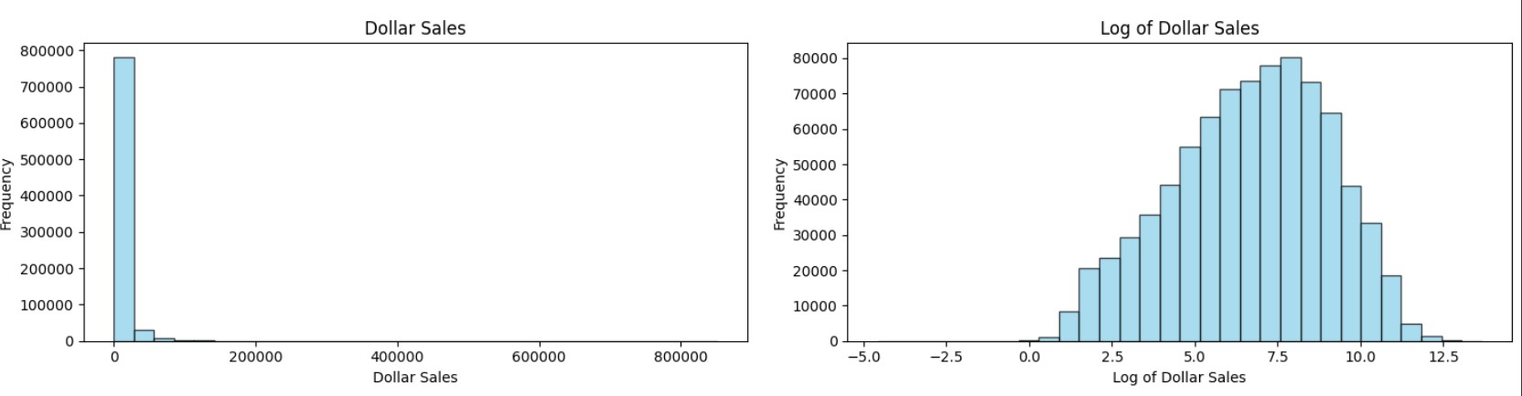

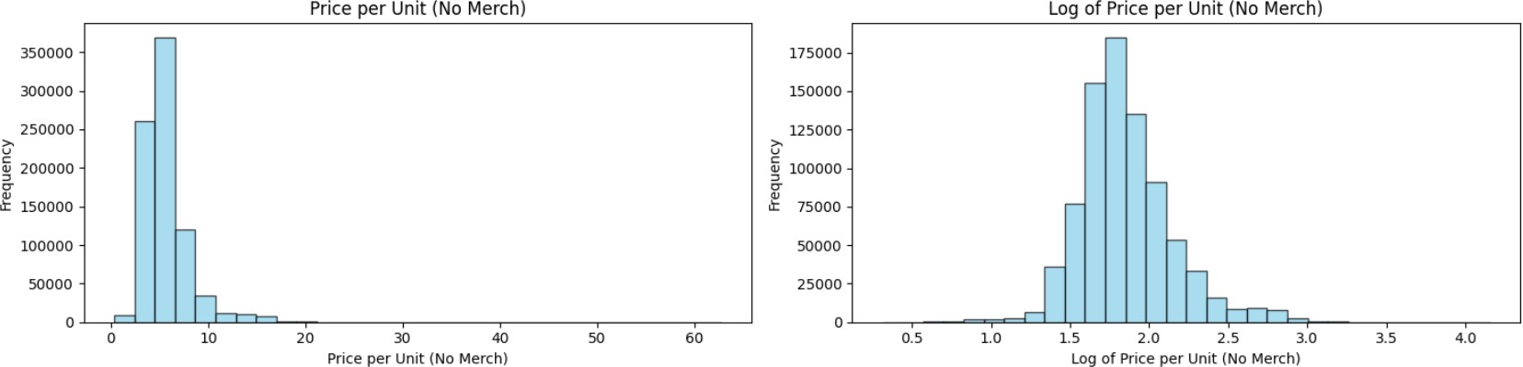

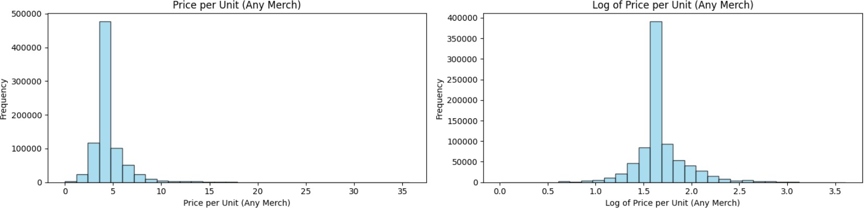

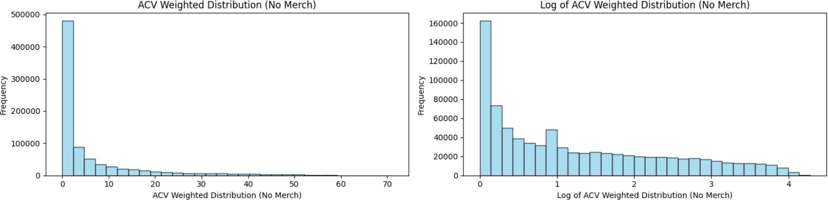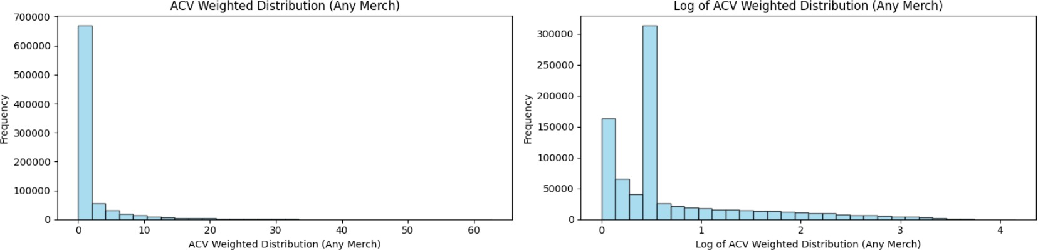

## RESIDUAL PLOT OF REGRESSION

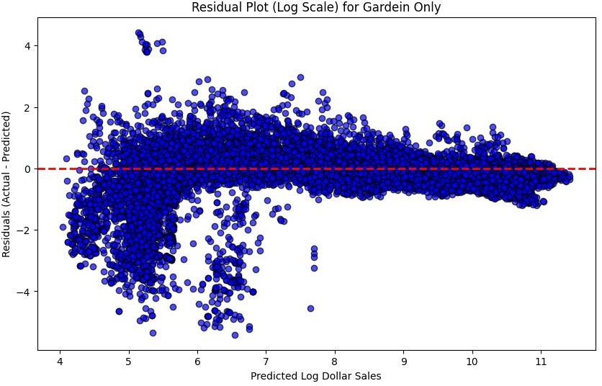

The residual plot for regression is good as the residuals are randomly present against the mean. This plot suggests there is little evidence of heteroskedasticity problem.

# ANOVA Outputs: Regional Analysis:

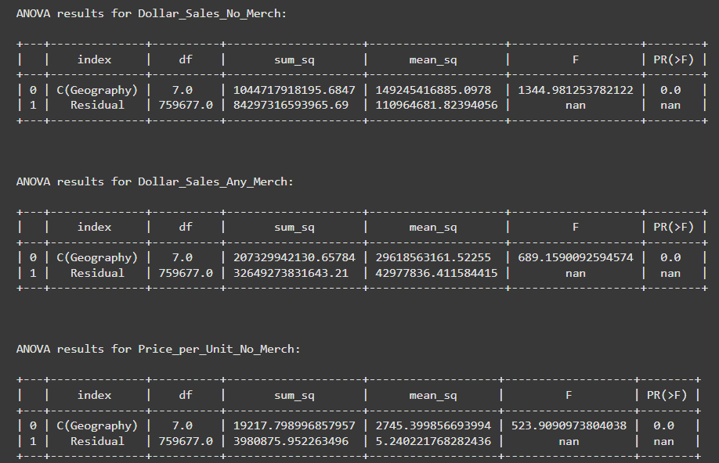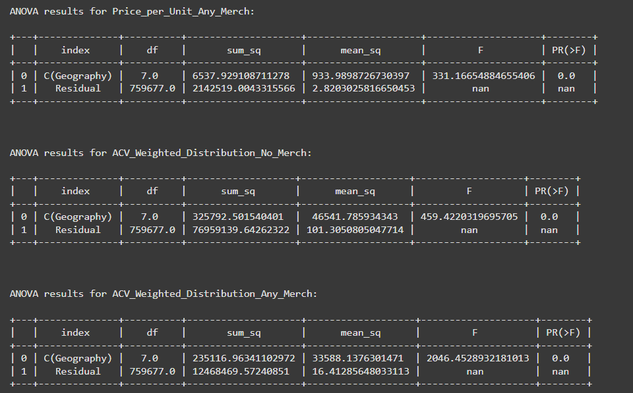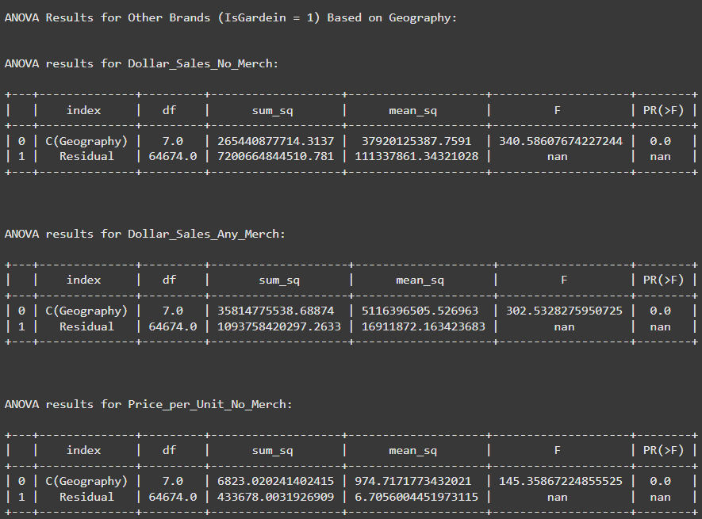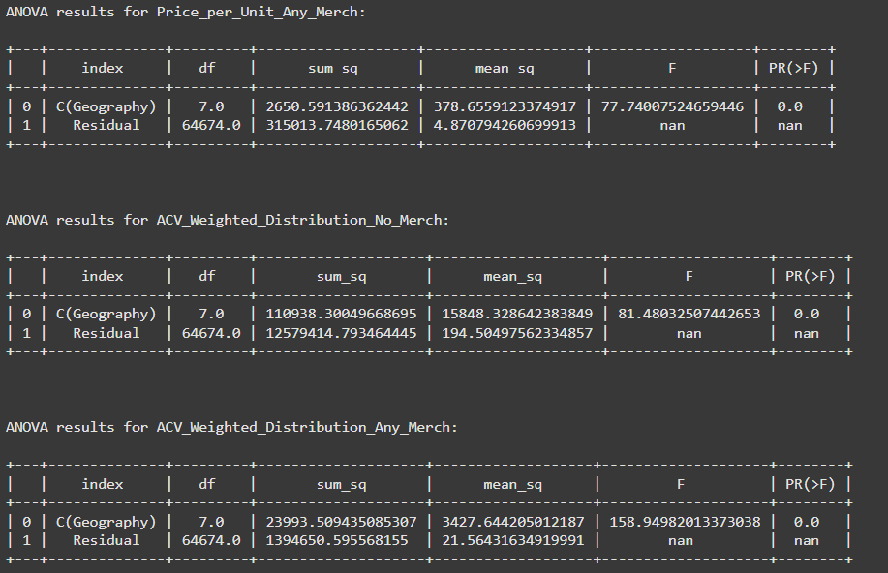

## Seasonal Analysis

